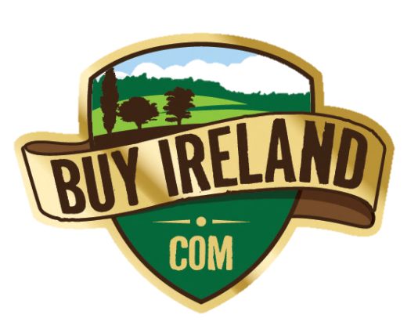
“Buy a piece of Ireland for only $49.99”

- 100% Irish Crafted Gift -
BuyIreland.com

Our company Why us?

Have you always dreamed of travelling to or buying property in Ireland?
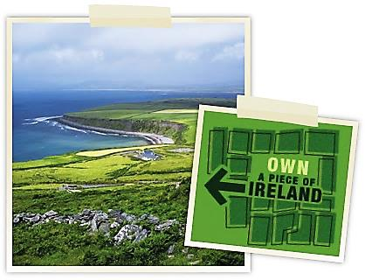
Did one or more members of your family emigrate from Ireland years ago, and you have always felt a historical connection to the beautiful island of Ireland?
Now, for just US$49.99 (with free worldwide shipping) you can purchase a small plot of land, one square foot in size, in rural Ireland.
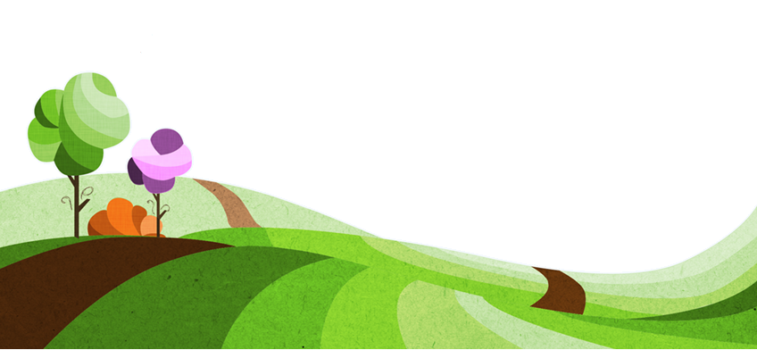
We will send you formal legal documents certifying your ownership of the property, as well as a map and address details showing you how to locate your property, should you ever have the opportunity to visit in person. You'll also receive two photographs of the stunning surrounding area.
Whether you're looking for a truly unique and thoughtful gift for someone special, or an inspiring and original corporate gift, or you just want to celebrate your love of Ireland by owning a little piece of it - you've come to the right place.

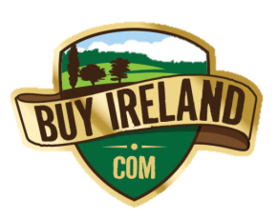
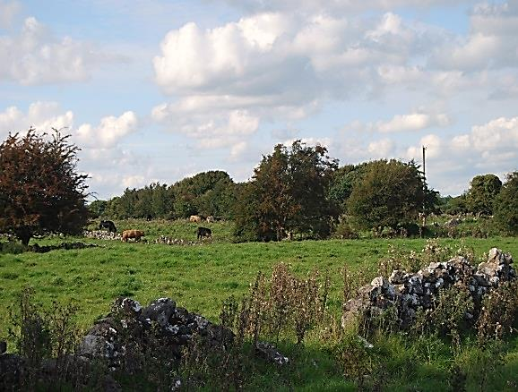
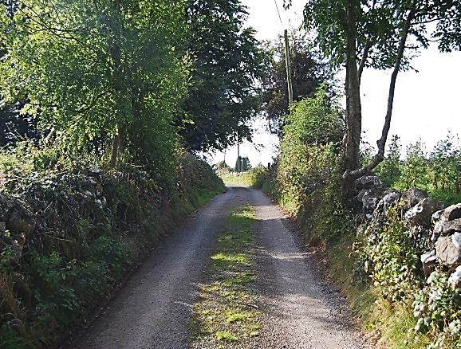
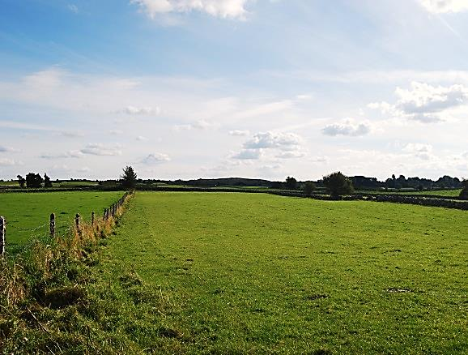

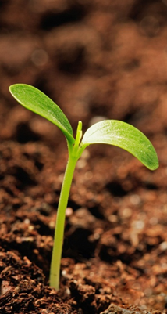

Our mission

BuyIreland.com was founded by John Beckett and Thomas Linehan in 2003. We recognised that Ireland holds a very special place in the heart of millions of people around the world, but for many of these people, visiting or owning property in Ireland is a dream that may never come true.
Endless planning went into this scheme which allows people from all walks of life, wherever in the world they may live, to own a small plot of land - one square foot in size - in the beautiful rural countryside of Ireland, without the normal expense and trouble involved in the purchase of property.

We are dedicated to giving access to the wonders of our beautiful countryside to as many people as possible. We hope that the very reasonable price we charge will allow everyone who calls Ireland their spiritual or ancestoral home, or who simply admires the rich cultural and natural diversity of our country, to be able to say that they have their very own piece of Irish countryside.
We welcome land owners to visit their plot and we include directions and detailed maps showing how to reach your plot with every order.

What you get?

It is our aim to bring a smile to the face of everyone who opens a package from BuyIreland.com. It is a fun and original gift pack, and is professionally produced with the highest quality materials.

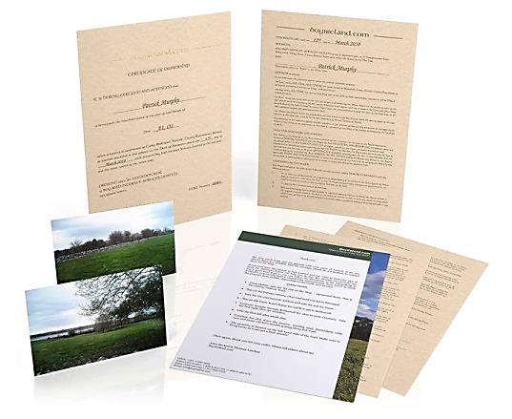

A Certificate of Ownership

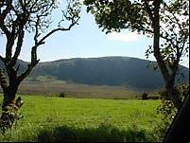
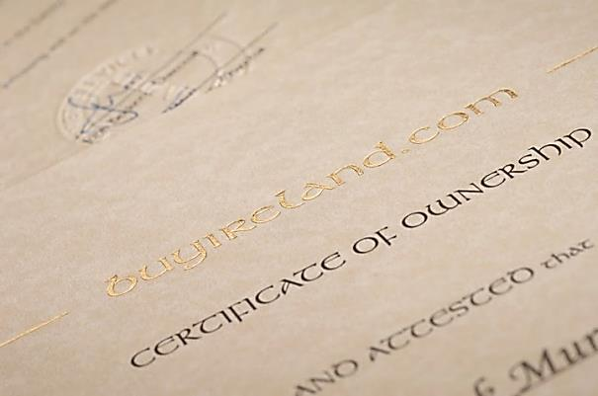
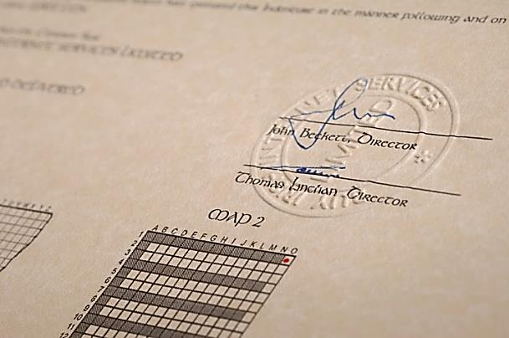

A Deed of Assurance

Photographs

Directions

Ireland is famous for its poor signposting, so we decided it was important to include detailed directions to help you find your plot of land should you ever have the opportunity to visit in person!
We include two photographs of the land with each plot. The photos are good quality prints and are also suitable for framing if you wish.
The certificate is printed on high quality parchment paper and has details of the plot owner, the individual plot number assigned to the owner, and an individual certificate number.
The deed fully outlines our responsibilities to you as owners of the land, and also outlines the rules that must be adhered to when you visit your plot. We have mapped out special paths or rights-of-way to help you locate your property on the grid maps attached to the deed.
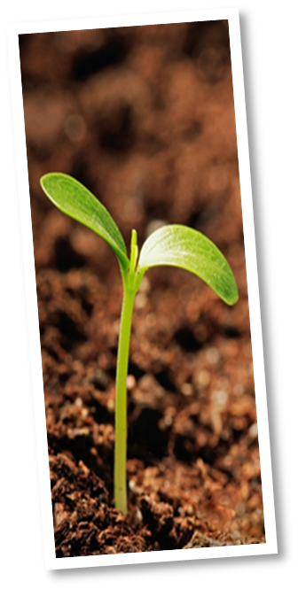

Contact Us

Sales Phone (US & Canada Only): 1-888-8-BUY-IRL (1-888-8-289-475)
Sales Phone (International): +1-813-882-5302
Office Phone: +353-1-280-5692
Fax (US & Canada Only): 1-888-9-BUY-IRL (1-888-9-289-475)
Fax (International): +353 (0)1 6972783
Email:info@buyireland.com

All postal queries should be sent to our offices, located at the following address:

BuyIreland.com
Anglesea House,
Suite 10,
Blackrock,
County Dublin,
Ireland.


BuyIreland.com is owned and run by Buy Irish Internet Services Limited, based in the Republic of Ireland. Our company registration number is 379442 and the registered business address is:
7 Fairview Strand, Fairview, Dublin 3, Ireland.

The information above can be confirmed by visiting the Irish Companies Registration Office Website: www.cro.ie

